Training for:
2021 Summer Administrative Retreats
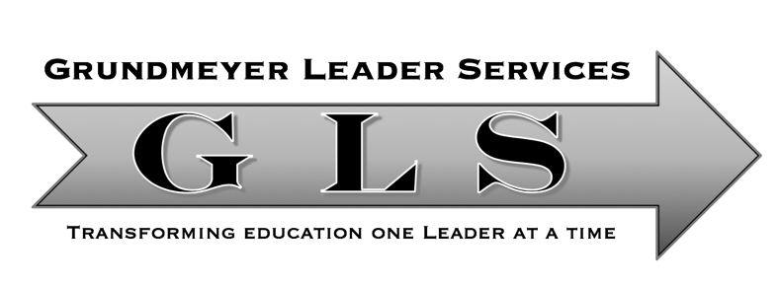

Whoever you are, be a good one.
-Abraham Lincoln

Desired Outcome(s): Use the ADVanced Insights Inventory, that combines the best of three researched based world-class tools, to help staff understand and leverage their natural talents.

Workshop Objectives
Understanding and skills to interpret
- Attributes Index
- DISC Index
- Values Index

Other Potential Uses:
- School Culture Building
- Teacher professional development
- At-risk/Alternative program
- Counseling program/lessons
- Mental health supports
- Academic and behavioral intervention plan
- Gifted programs
- Parent teacher conferences
- Special education/IEP’s

The Genius Study

The Question
The question was asked, “Why do some people consistently achieve much greater success with less effort, while others - who work just as hard, are just as intelligent, and even work in the same environment - achieve much less?”

Performance metrics
    - Level I - Below Average
    - Level II - Average
    - Level III - Above Average
    - Level IV - Excellent
    - Level V - Genius

The Findings of the Research
- No statistically significant correlations between performance and any natural talents
- All roles, all industries, all levels
- Two acquired skill sets (Self-Awareness & Authenticity)

Meaning:
- Anyone can achieve the 5th Level of performance
- But it requires concrete
  - Self-awareness
  - Authenticity

Turning Right more than Turning Left
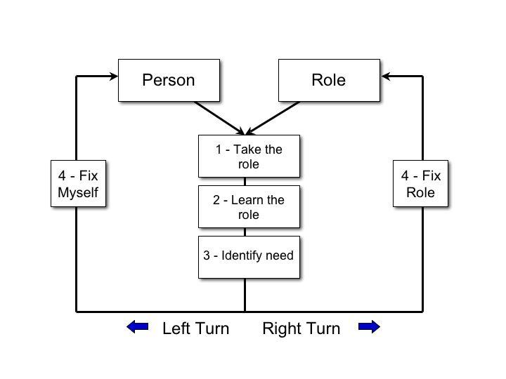

Hyper Successful People Have 2 Things in Common:
- Self-Awareness
- Authenticity

Unlock Your Inner Genius…….
JUST DO YOU!

Powerful Words

Powerless | Takes Away Our Power | Words that Create Power
Shouldn’t, Should | Allows us to live with regrets | I will or won’t
Never or Always | Sets up doubt and failure
Have to, Need to, Must | Creates pressure and stress | We have a choice, a decision to make – I GET to, WANT
Can’t | Limits us, takes away our control | I will–it’s my choice
Try | You either do or you don’t | I will, I won’t

Know Thyself
“Knowing others is intelligence; knowing yourself is true wisdom”
- Socrates

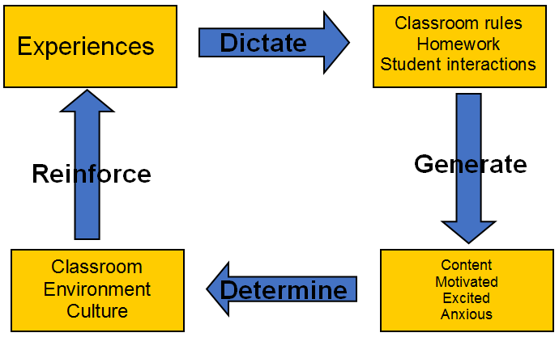

Overview of the Profile
- What Talents – Decision Making Style (Attribute Index)
- How Use Them – Behavioral Style (DISC Index)
  - Natural vs Adaptive
- Why use Them – Motivational Style (Values Index)

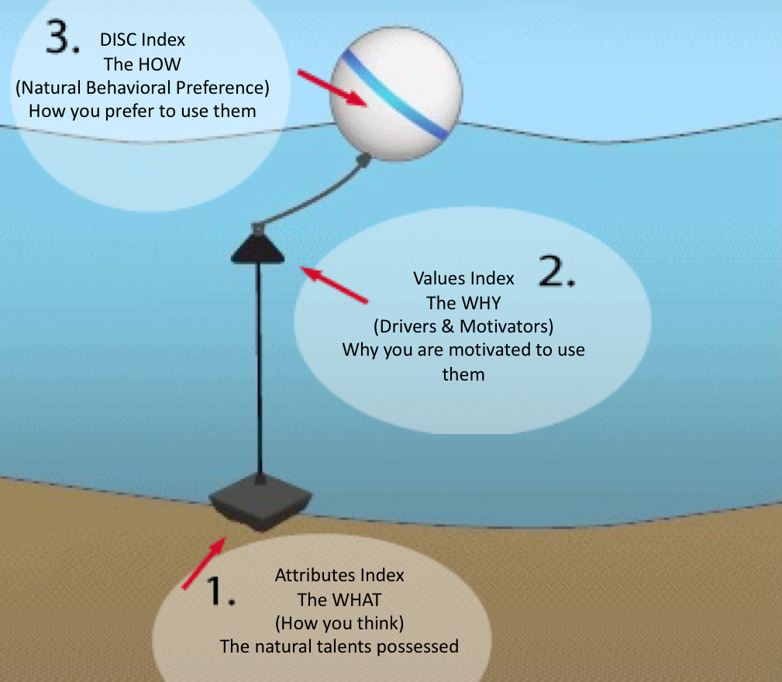

Characteristics of DISC
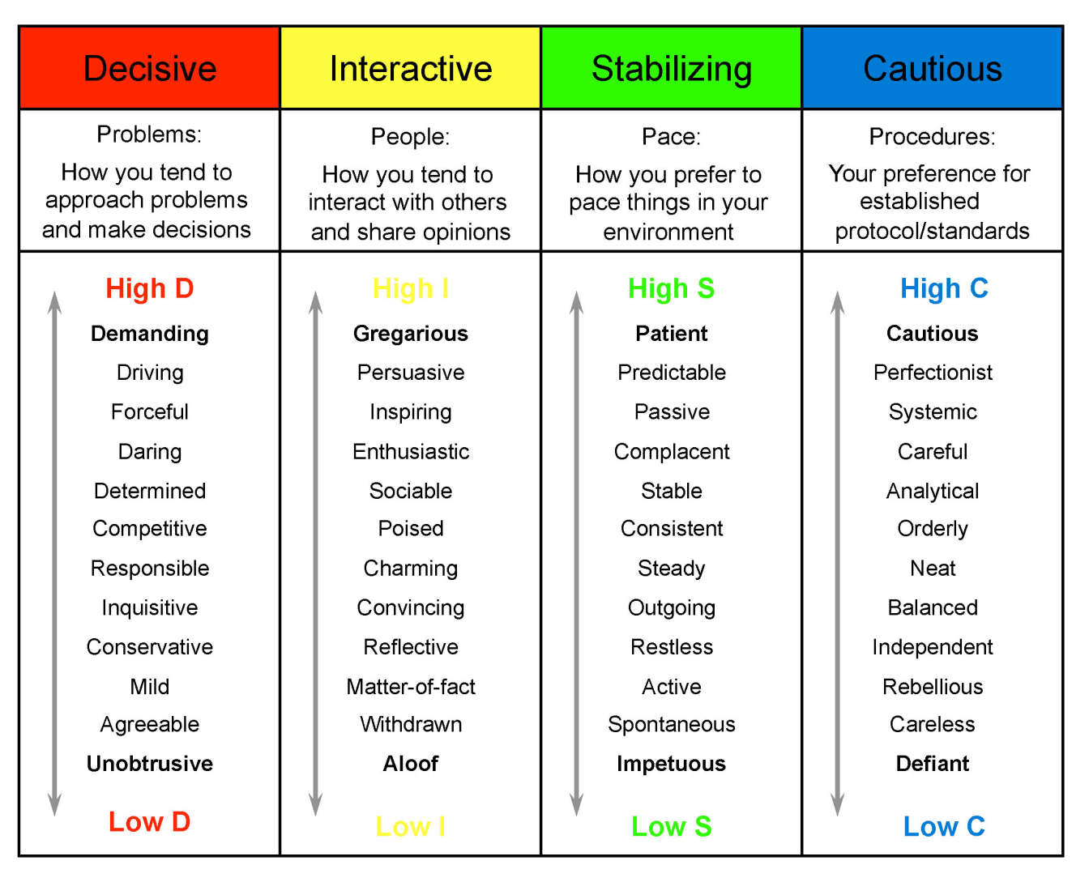

Observable Characteristics of DISC

High D | High I | High S | High C
- Likes new ideas projects and innovations  - High ego factor  - Wants the “bottom-line” – NOW  - Impatient, energetic, and restless  - Impulsive, decisive, direct & to the point  - Faster paced conversation  - Closed answers to your questions  - Cool & distant  - Expresses emotions directly  - May interrupt you frequently during your conversation | - Friendly, people-oriented  - Will be glad you called; may trade jokes and stories  - Won’t discuss business too much  - Likes to do new & innovative products and ideas  - May be a name-dropper to see who else is……..  - May be your “coach” and everyone’s coach  - Faster-paced conversation  - Open answers to your questions  - Lively animated speech  - Color & enthusiasm in voice  - Quick responsiveness  - May get off-the-track of your conversation | - Somewhat shy, but will warm up after you have developed credibility  - Rather slow to make changes  - Not an “innovator”, but likes proven, traditional concepts  - Family oriented, member of groups, loyal  - Lower sense of urgency to get things done  - May complain about the “rush” of deciding now  - Slower-paced conversation  - Open answers to your questions, especially after they trust you  - A bit warmer that the “C” style, but still rather unemotional  - Reserved but friendly style | - Suspicious of you and your solutions  - Doesn’t make changes readily  - Not very talkative  - Usually not an “innovator”.  - Will not readily approach the new and innovative  - Ruled by logic, not emotion  - Slower-paced conversations  - Closed answers to your questions  - Unemotional Cool/distant  - Little variation in voice.  - No-nonsense

Understanding Natural vs Adaptive
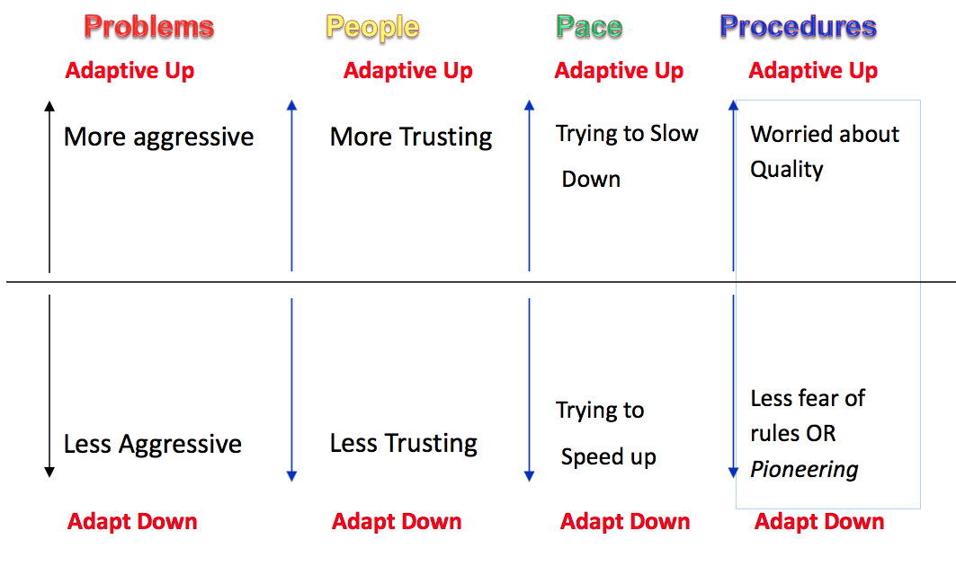
Sample DISC Profile
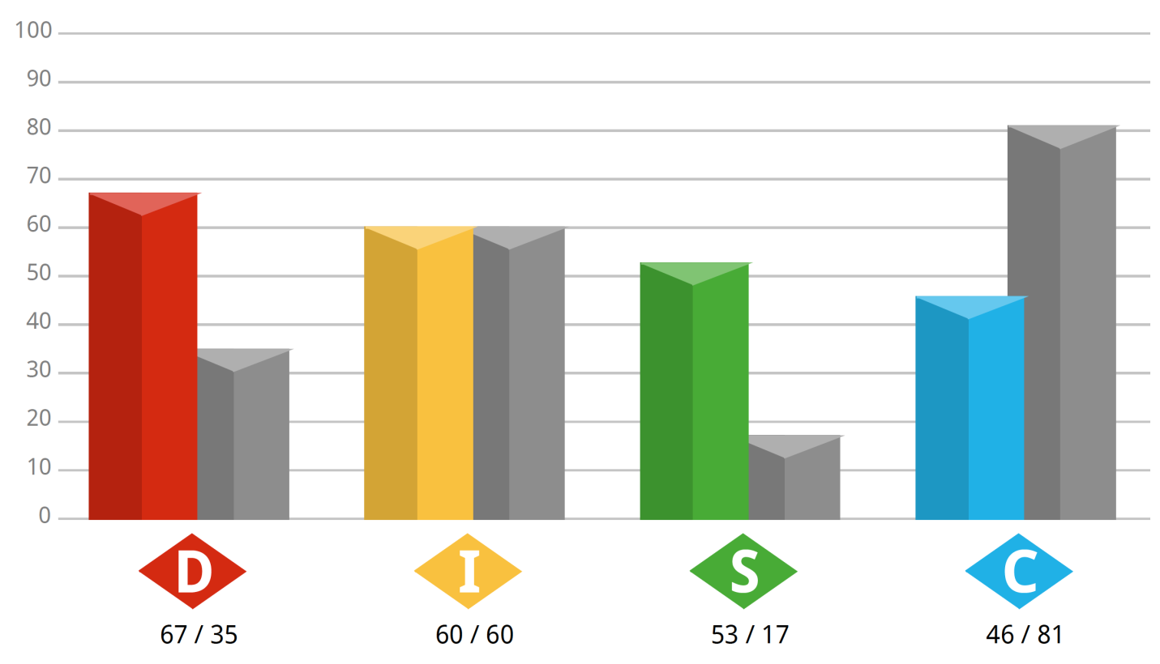

Emotion Aligned to Priority

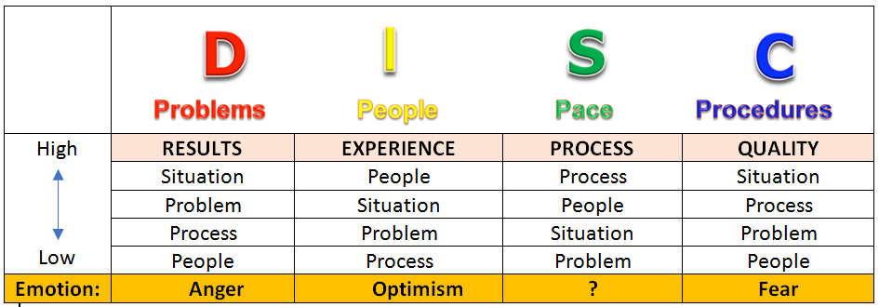

DISC Graph Sample Exercises (Match the profile with a career)

DISC | NOTES | POSSIBLE CAREER
- D – 28

I - 99
S - 60
C - 10
- D – 88

I - 40
S - 99
C - 65
- D – 70

I - 19
S - 12
C - 8
- D – 82

I - 99
S - 99
C - 77

DISC Colleague Examples (Generate DISC profile numbers for each)
DISC | NOTES | POSSIBLE CAREER
D - _____  I - _____  S - _____  C - _____ |  | Most charismatic person
D - _____  I - _____  S - _____  C - _____ |  | The calmest staff member
D - _____  I - _____  S - _____  C - _____ |  | The best coach in the school
D - _____  I - _____  S - _____  C - _____ |  | The biggest complainer on staff
D - _____  I - _____  S - _____  C - _____ |  | Pick a colleague!

DISC Talking Points:
- DISC demonstrates observable behaviors
- Observable means what others see
- Everyone has a natural and adaptive behavior
- Adaptive behaviors take more effort
- Adaptive behaviors are not normally sustainable
- The research suggests knowing yourself (self-awareness) and staying true to your natural talents (authenticity) is the key to genius level effectiveness
- ________________________________________________________________________
- ________________________________________________________________________

Values and Motivators
WHY do we do what we do?
WHAT motivates us to do what we do?

Defining Values and Motivators
Values help influence behavior and action and can be considered somewhat of a hidden motivation because they are not readily observable. Understanding your values helps to tell you why you prefer to do what you do. It is vital for superior performance to ensure that your motivations are satisfied by what you do. This drives your passion, reduces fatigue, inspires you and increases drive.

- Aesthetic - a drive for balance, harmony and form
- Economic - a drive for economic or practical returns.
- Individualistic - a drive to stand out as independent and unique.
- Political - a drive to be in control or have influence.
- Altruist - a drive for humanitarian efforts or to help others altruistically.
- Regulatory - a drive to establish order, routine and structure.
- Theoretical - a drive for knowledge, learning and understanding.

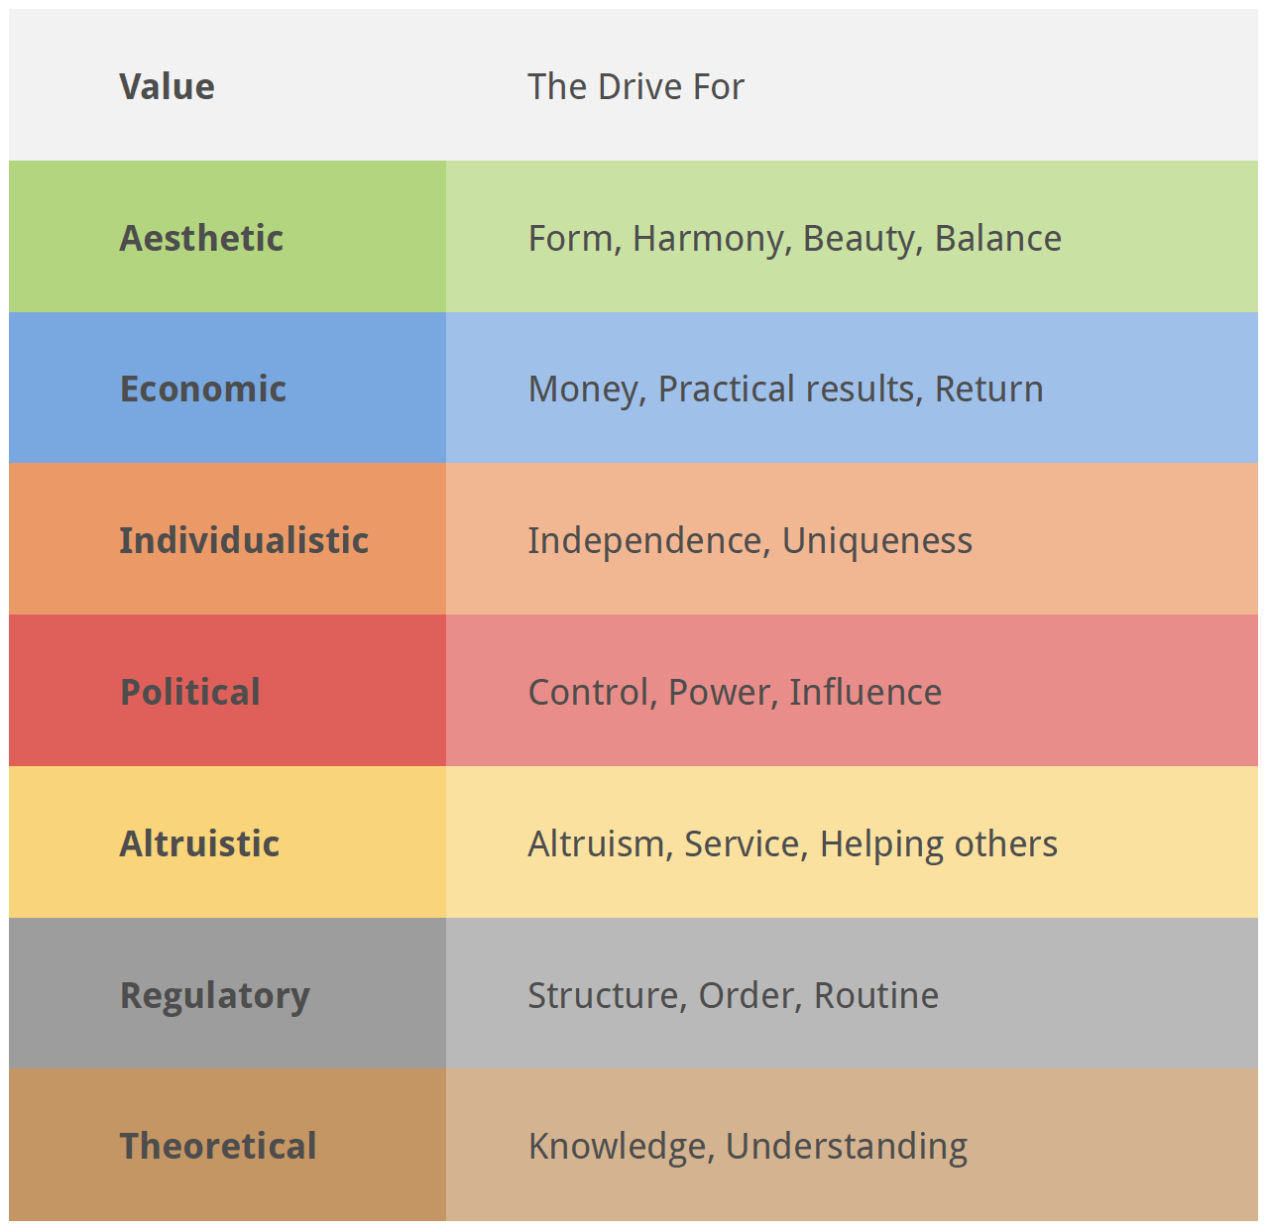

Describing Values and Motivators
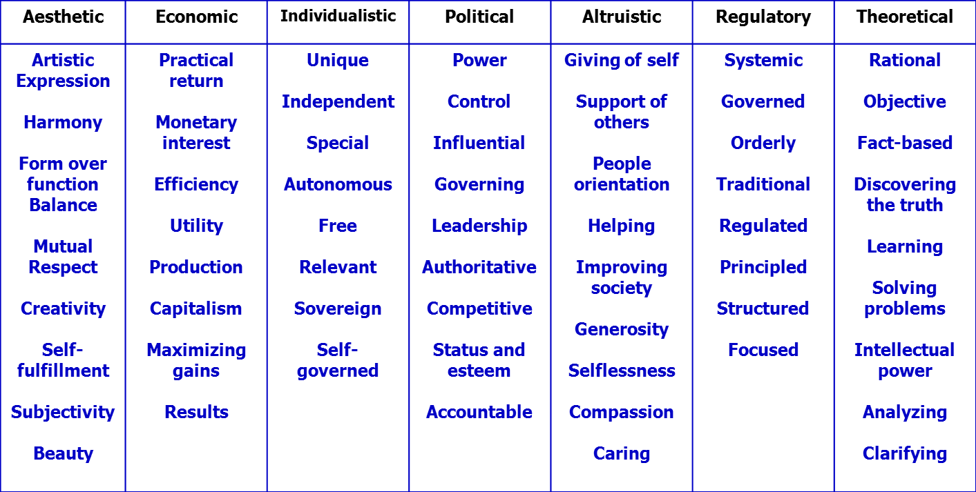

Understanding Values
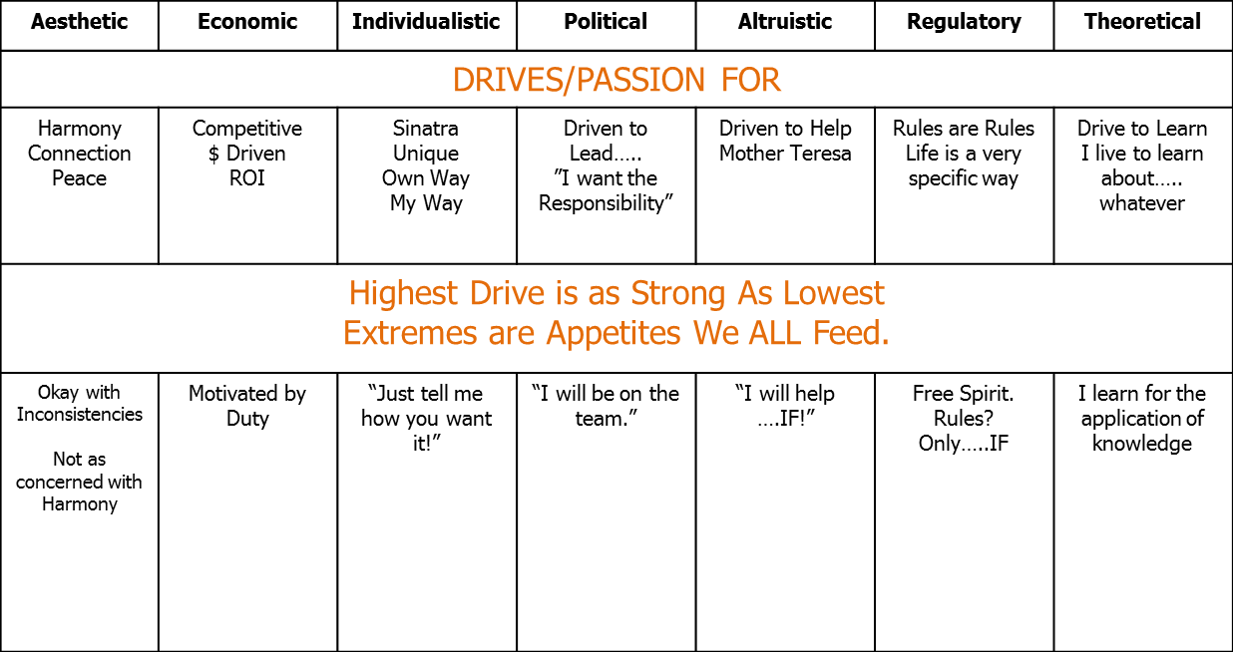

Align the Person to their Top 2-3 Values and Motivators
PERSON | NOTES | TOP VALUES/MOTIVATORS
Mother Theresa
Simon Cowell
Abraham Lincoln
Elvis Presley
Mark Cuban
Dr. Phil
Mark Zuckerberg
Jenifer Lopez

Credo: a statement of the beliefs or aims which guide someone's actions.
Write a short credo which highlights your values and motivators:

Values and Motivators Talking Points:
- Explains why we do what we do
- Highlights what motivates and can de-motivate people
- We tend to run toward values and motivators and run away from low values and de-motivators
- People tend to appreciate and connect with others with similar values and motivators
- Differences in values and motivators should be valued
- Good teams are comprised of people with different DISC profiles and values/motivators to be most effective
- Perspective leads to acceptance
- ________________________________________________________________________
- ________________________________________________________________________

Attributes Index
Order your brain processes information
- External
  - Empathy - seeing the humanistic, personal perspective, empathetic thinking, or with concern for understanding, connecting with the individual(s) involved. This style intuitively “gets” people. (HEART)
  - Practical Thinking - looking at things from a practical, real-world, results-oriented perspective, tactical or practical thinking, seeing things in no nonsense, real world, task-oriented manner. This style intuitively processes “getting” results and how things work. They love options and solutions. (HAND)
  - System Judgement - conceptual, structural perspective, strategic thinking. This style naturally sees the world from a theoretical, intellectual perspective, intuitively” getting the big-picture. (HEAD)
- Internal
  - Self-Belief – clarity on self and environments (personal, career, spiritual, etc.).
  - Role Awareness – clarity on roles (personal and professional).
  - Self-Direction – clarity on where you are going and your path to get there

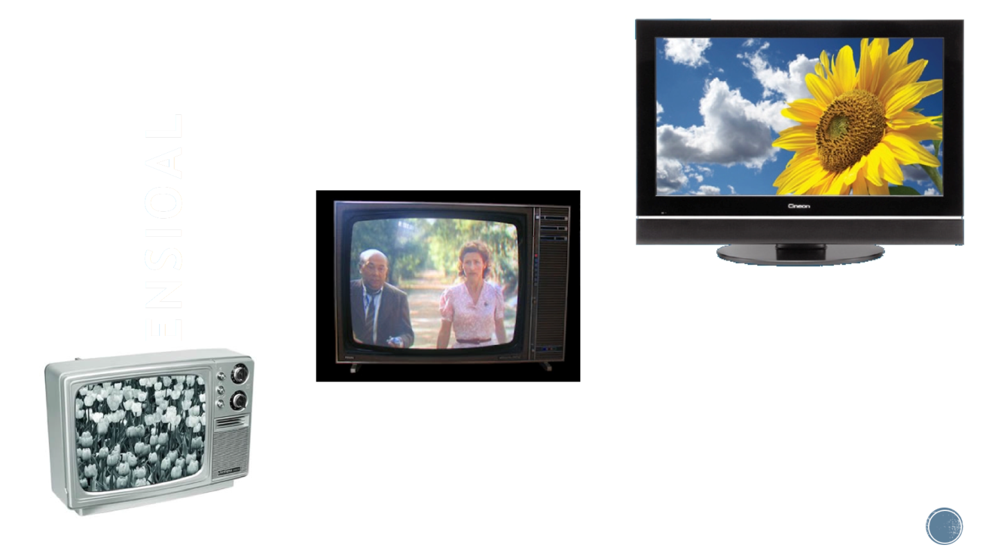

Dimensional Balance – How We Think of Self
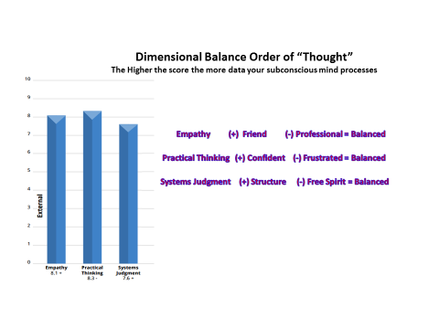
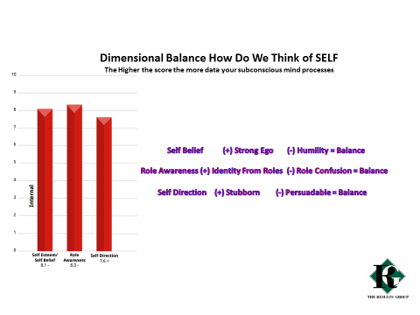

External Attributes Examples:

Empathy (Heart) | Practical Thinking (Hand) | Systems Judgement (Head)
Share a scenario where a person made a decision based on empathy for others over the best solution or long-term outcomes of the decision.  What are the benefits and cautions with this order of thought? | Share a scenario where a person made a decision based on practical thinking over thinking about others or the long-term outcomes of the decision.  What are the benefits and cautions with this order of thought? | Share a scenario where a person made a decision based on systems judgement over thinking about others or having the best solution.  What are the benefits and cautions with this order of thought?

Individual Reflection
Now that you have defined your order of thinking (as defined by the attributes index) …
1. Where in your personal life does your order of thought impact your decision making?
2. How do you believe your order of thought process benefit the teams you serve?
3. How can you use this information to enhance your value to the team?

Talking Points on External and Internal Attributes:
- Attributes measure “Order of thought”
- External attributes tend to be higher
- External attributes tend to change less than Internal attributes
- Internal attributes changes based on experiences and situations
- The high an attribute the more clear
- __________________________________________________________
- __________________________________________________________

Application of Profile

Look at your Attribute Index Report Advanced Scoring Page as a sample:
MY NATURAL STRENGTHS ARE (Pg. 19): | HOW I UTILIZE THEM IN MY WORK ROLE:

MY IDEAL JOB/CLIMATE (Pg. 20): | HOW I UTILIZE THEM IN MY WORK ROLE:

AREAS FOR CONTINUAL IMPROVEMENT (Pg. 21): | HOW I UTILIZE THEM IN MY WORK ROLE:

PREFERRED TRAINING AND LEARNING STYLE (Pg. 19): | HOW I UTILIZE THEM IN MY WORK ROLE:

COMMUNICATION INSIGHTS FOR OTHERS (Pg. 23): | HOW I RELY ON THEM IN MY WORK ROLE:
Notes

