Colo-NESCO Stakeholder Survey Report

The Colo-NESCO School District completed a stakeholder survey from Oct. 27-Nov. 8th which resulted in 85 total responses from students, teachers, support staff, parents, community members, administrators, and alumni. The results provided some great insights for the district in regard to strengths, areas of concern and what stakeholders are looking for in a new superintendent.

Survey Participation

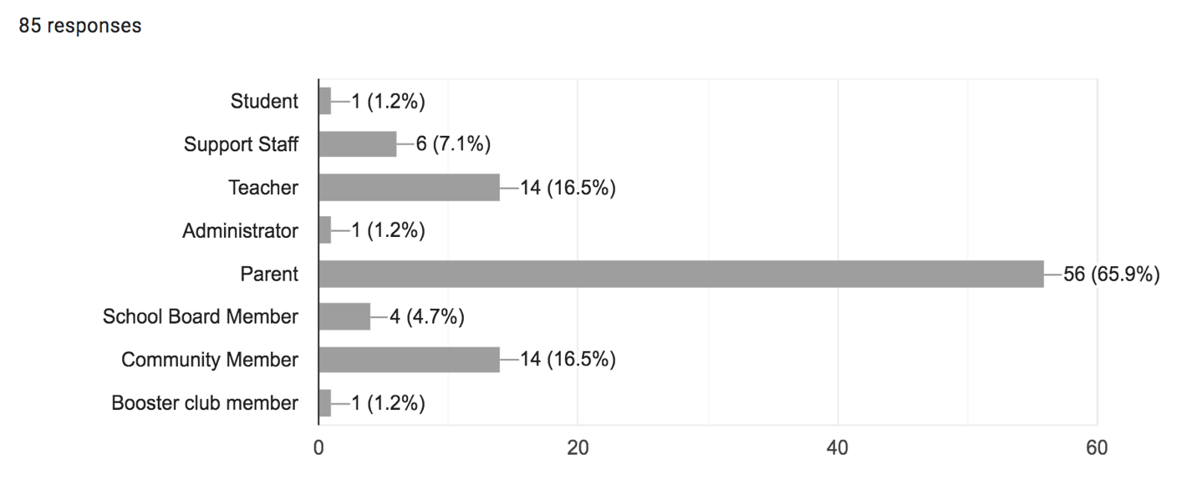

What are the strength areas or points of pride for the Colo-NESCO School District?

- Community support for the school district
- Small class sizes
- Caring and supportive teachers
- Teamwork and collaboration
- School improvements/bond issue

Colo-NESCO is a small, tight-knit community that is near to large cultural centers of the State of Iowa. Many students at Colo-NESCO are able to be involved in an abundance of sports and activities, and the support from parents is strong.

Teaching staff is fabulous, dedicated. Lots of great opportunities for high school students to work with younger students.

Caring staff who really get to know their students and are invested in student success.

Smaller school. Kids can participate in many different activities. Staff knows and cares for Every student.

Our community/family feel at our school. Working to improve our school performance, always trying to get better. Doing what's best for individual students and finding alternatives to the traditional classroom experience if that is needed. Teachers and staff collaborating on best practices.

Strong sense of community. Small size allows for strong relationships between students, staff, and families.

Passing the bond for the school improvements; small class size (both positive & negative)

We have good kids, good parents, and we have three towns that are proud of our school.

What are challenges or areas for improvement for the Colo-NESCO School District?

- Bullying and
- Academic opportunities and rigor (Secondary Report Card)
- Declining enrollment and open enrollments out
- Staff retention
- Lack of childcare
- Facility updates (weight room, fine arts, classrooms)
- Unity three towns

I can't think of a single one. The school is so poorly run that it should be dissolved and consolidated with other districts, both for financial reasons and academic reasons.

Making good fiscal decisions, thinking long-term, trying to find ways to attract families to the district

Clear & Timely Communication using all outlets (e-mail, mail, website, Facebook, fliers). Questionable curriculum implementation (e.g., guidance/yoga/mediation).

Greater cooperation between the three communities.

Decreasing enrollment might be the root cause of many challenges at Colo-NESCO.

The facilities, while improving, are still an area of improvement for the district.

Before/after childcare needs cause a lot of parents to open enroll elsewhere.

Teacher retention. We have teachers that have been here a long time, and then a bunch that use us as a stepping stone to something different. We need to attract and keep teachers who may not want to be her for 30 years, but definitely want to invest in our district for more than 2 or 3 years

Having three towns making up our school district, it is hard to make everyone feel like they have an equal part of the district.

Please check the 3 most important professional skills and qualifications you hope to have in a new superintendent.
- Builds school and community relations (36.5%)
- Recruits, hires and develops a strong administrative team (30.6%)
- Strong instructional leader (29.4%)
- Models the districts vision and mission (24.7%)
- Promotes a community of care and support for students (24.7)%)
- Meaningful engages with families and the community (24.7%)
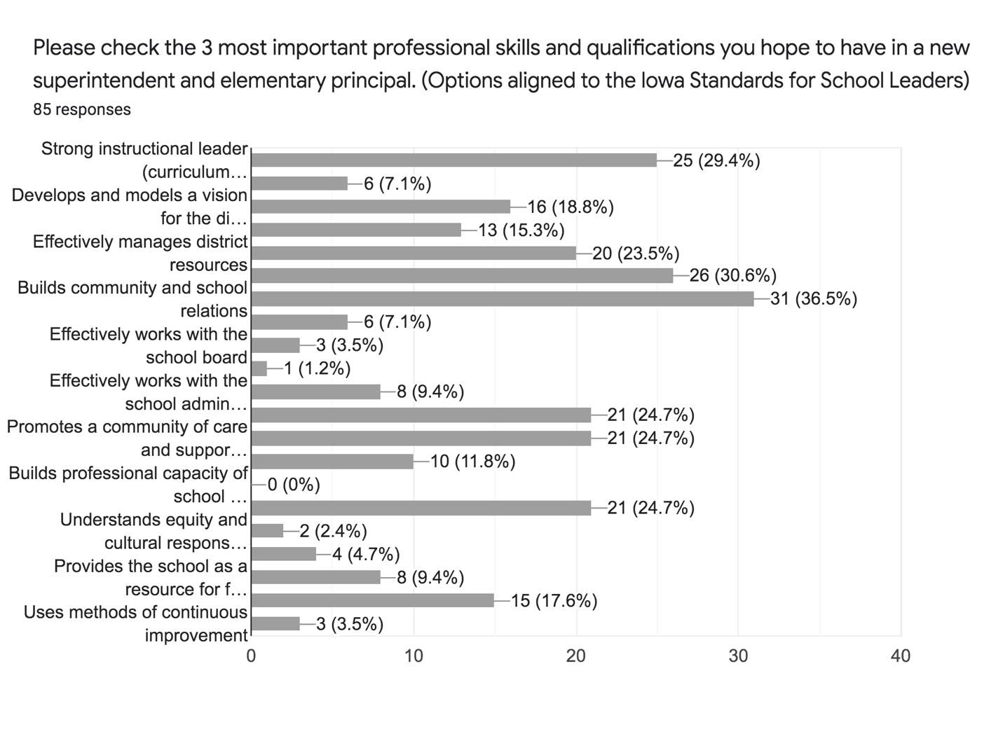
Please check the 3 most important personal traits or qualities you hope to have in a new superintendent.

- Is approachable, accessible and welcoming (76.5%)
- Follows through on tasks and responsibilities (41.2%)
- Demonstrates ethics and integrity (36.5%)
- Possess strong communication skills (32.9%)

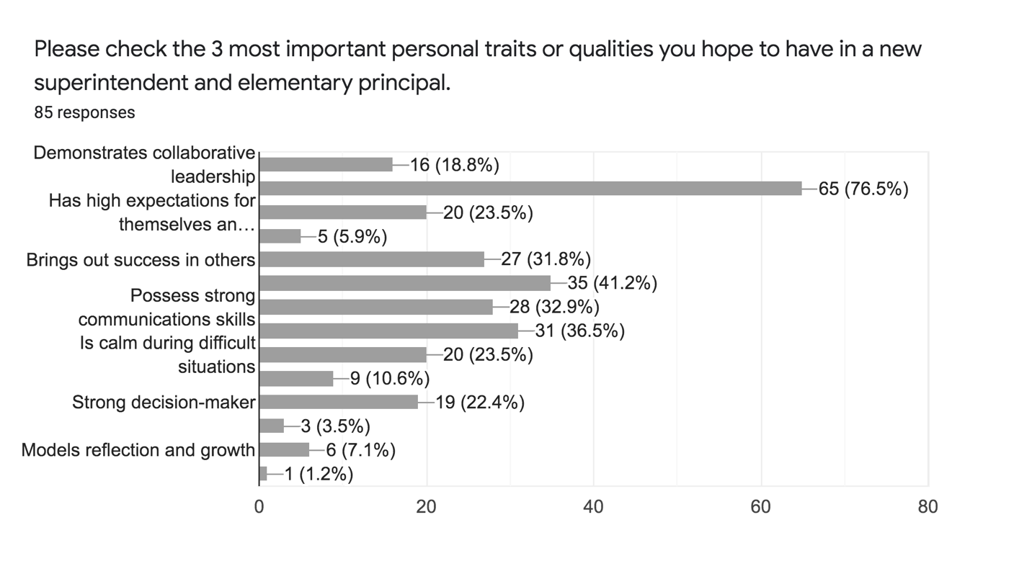
Why do you believe these qualifications and traits are most important for the new superintendent and elementary principal?

I feel this position is one that the kids and staff should look up to and feel safe and be a good leader to follow.

I think as both a principal and superintendent it is important to be welcoming to both students, staff, and parents.

A good leader keeps his staff and student's best interests in mind through remaining calm and following through with expectations. Being approachable and welcoming puts families as well as students and staff at ease. Life is hard enough right now, everyone needs to work together.

We need someone willing to keep pushing to do the best for the district.

You must have support from this community to maintain this school district. Communication with all community members is vital.

A leader needs to create a sense of community within the district while still providing a concise plan and demonstrating leadership. That person also needs to have buy in from the school staff and try to bring out their best so they can in turn bring out the best in our students.

We are a small district/community and our school is what brings us together. When I see our superintendent at city council meetings, school meetings, sporting events and FFA banquets (just to name a few) I know he is engaged and committed to the success of our district.

They need to be approachable and willing to work for our students.

Advice for the new superintendent:

