Grundmeyer Leader Search
  - Transforming Education One Leader at a Time

www.grundmeyerleadersearch.com

Dr. Trent Grundmeyer

Trent is the founder of Grundmeyer Leader Search LLC. Prior to his tenure at Drake University serving as an Assistant Professor of Educational Leadership he served as a high school principal at Hampton-Dumont and Indianola High School. Trent was recognized as 2013 Secondary Principal of the Year by the School Administrators of Iowa organization. He earned his doctorate degree in educational leadership at Iowa State University in 2013 and focuses much of his research around technology integration and leadership. Grundmeyer Leader Search continues to grow based on Trent's integrity in the search process ensuring that the leader who gets hired is truly the best fit for the job.

TO PartnerS & Interested SPONSORS,

Grundmeyer Leader Search (GLS) is a search firm aimed at Transforming education on leader at a time. The firm has grown significantly over the years because of quality service to districts at a fair price. Our quality service includes 21st Century recruiting measures, advanced screening tools, and a clear process that leads to candidates who are truly the best fit for the district.

GLS recently conducted leader searches for Charles City, Tipton, Sioux City, Manson Northwest Webster, Mason City, Woodbine, Clarinda, North Polk, Carroll, South Hardin, Eddyville, Melcher-Dallas, and Lamoni schools, among others. For a full list of successful hires visit the search firm website at www.grundmeyerleadersearch.com.

GLS strives to make the selection process professional, efficient, and successful to assure your complete satisfaction. The firm already has many partners that complement their service to schools. Thanks for considering being one of those partners.
Thanks for your consideration,
Trent Grundmeyer

OPPORTUNITY
Each page on the search firm website has a “Search Firm Partner” spot at the bottom of the page. There are 5 pages that do not have a sponsor or partner on them:

Search Process Page ($250/year)
Active Searches Page ($1000/year)
Consultants Page ($450/year)
Successful Searches Page ($450/year)
Guided Search Process Page ($450/year)

Some pages tend to have more traffic than other. The pages are being sold to you based on the specific traffic they have. Keep in mind that the traffic on most pages is specific to the viewers interest. For example, usually school board members are viewing the Consultants Page and usually potential applicants are looking at the Active Searches Page.

WEBSITE TRAFFIC BY PAGE
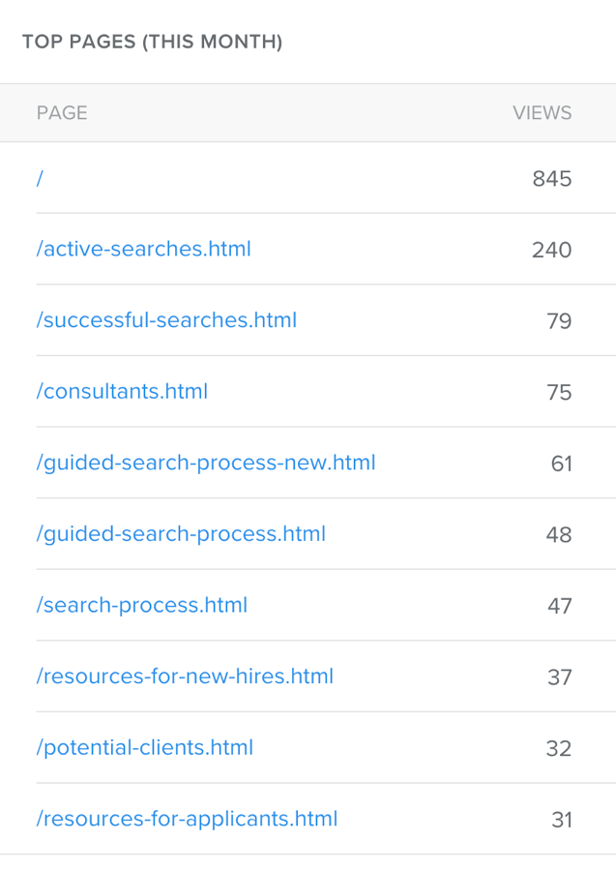

OVERALL WEBSITE TRAFFICE
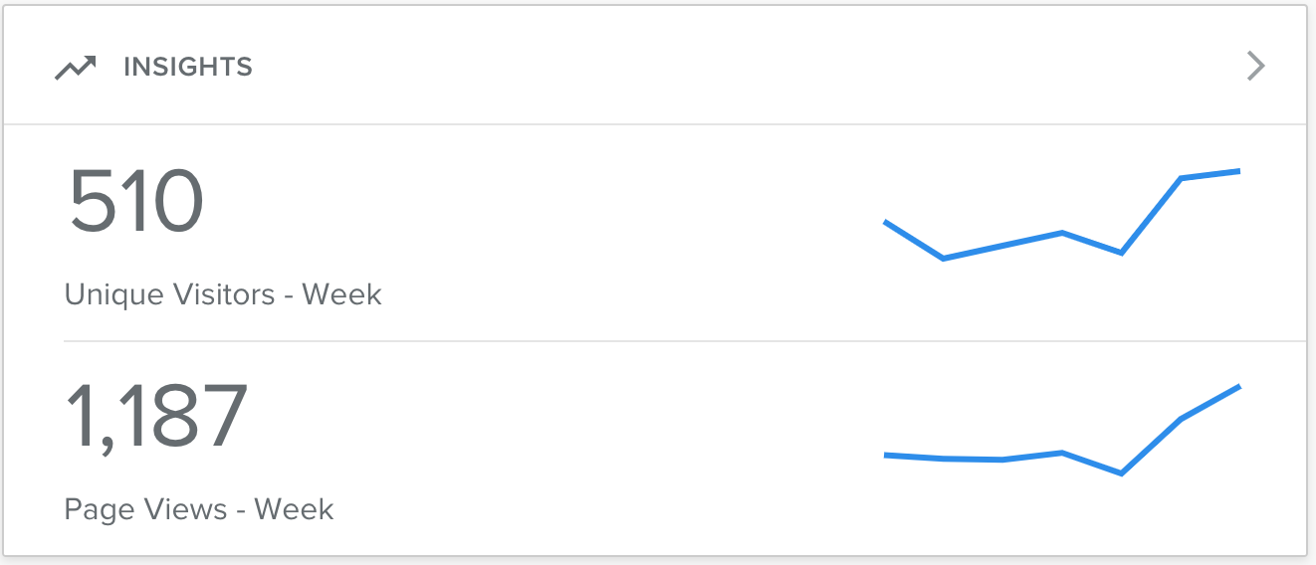
TIMELINE
If you elect to be a partner you would be billed on July 1 for a full year sponsorship. You will automatically have the chance to renew each year with a prompt on May 1 to renew prior to June 30th. You can cancel your sponsorship at any time for the next year by putting your request in writing to tgrundmeyer@gmail.com or sgentz@bsgstrategies.com.

July 1 Start of sponsorship on website
May 1 Renewal correspondence
June 30 Payment due

PAGE GRAPHIC
Once you decide to sponsor GLS we will work with you to create a small graphic with contact information about your business or organization. Your logo and contact information will show up at the bottom of the page you sponsored. Please visit the website to see current sponsors.

