Harlan Stakeholder Survey Report
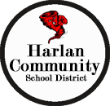

The Harlan School District completed a stakeholder survey from October 27 through November 8 which resulted in 300 total responses from students, teachers, support staff, parents, community members, administrators, and alumni. The results provided some great insights for the district in regard to strengths, areas of concern and what stakeholders are looking for in a new superintendent.

Survey Participation

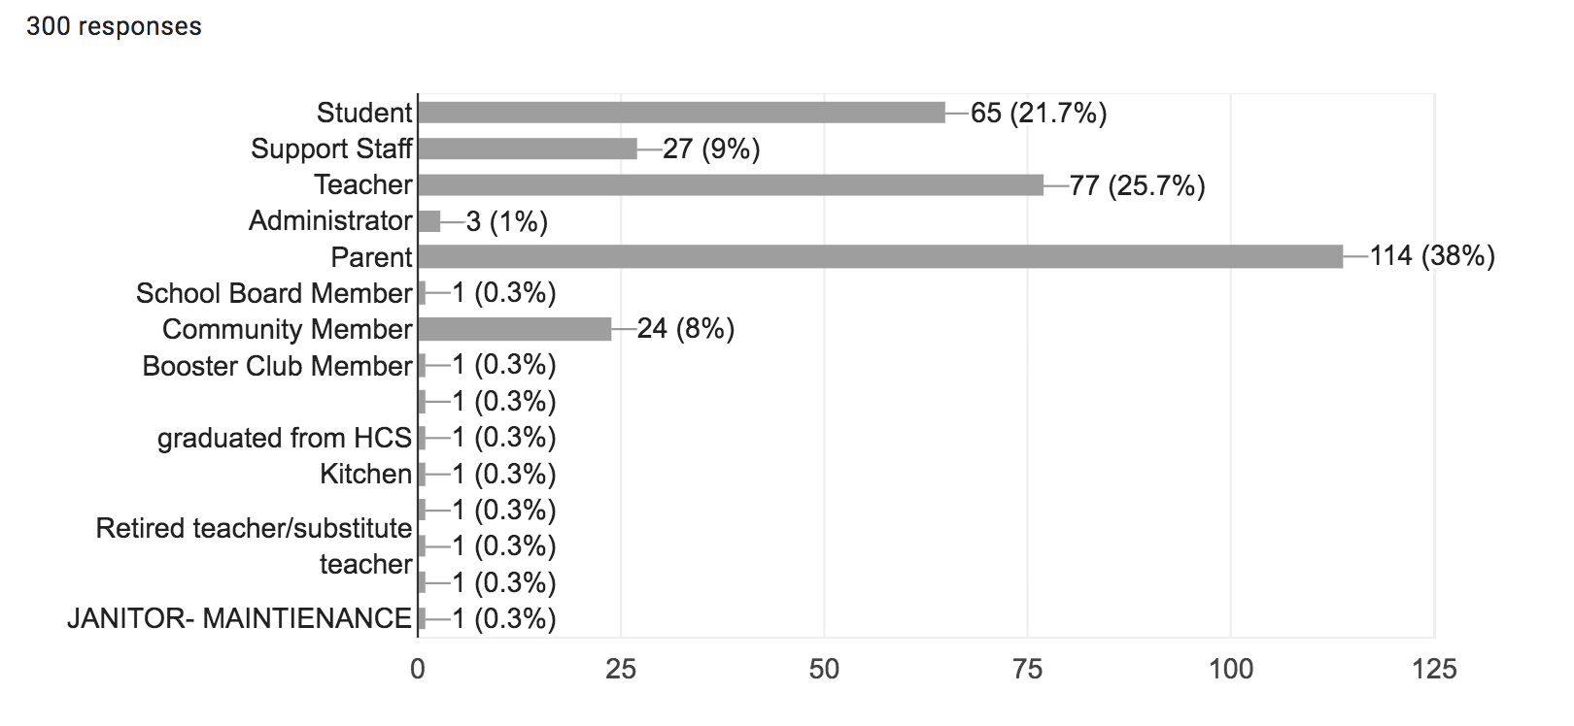

What are the strength areas or points of pride for the HARLAN School District?

- Sports and Fine Arts Programs
- Academics
- Supportive community
- School pride
- Quality students and families
- High standards for students and staff

We are a community and we do what is best for the students and staff!

Top tier education and sports program.

It is amazing to see how many former alumni return to this community to ensure that their families are given the same upbringing and educational experience that they themselves received.

Extra Curriculars and Academics go hand in time.

I think that HCS provides a quality education with a lot of opportunities for students outside the classroom as well.

We have an excellent community spirit-this is due to the parental support of the school, the professionals that educate the students and the students themselves are top notch.

We have a reputation for excellence, that although has waned in areas, we remain committed to high standards.

Tradition, strong academics, school pride, strong extracurriculars.

The Harlan School district has done an outstanding job through the years at developing mature, kind young adults. Keep up the good work.

High academic achievement for all, excellence in activities, and teachers that give it their all and more every day to help students meet their goals.

School provides a quality education that prepares students for both college and the workforce.

What are challenges or areas for improvement for the HARLAN School District?

- Retention and support for non-certified staff
- Developing vocational/trades programs
- Facility improvements (high school mentioned most)
- Declining enrollment
- Communication (between buildings and administrators and to parents)
- School culture for staff

Not recognizing sports other than vball/b-ball/football, focusing too much on sports and not enough on academics and the clubs.

Some of the challenges we face is keeping up with the vocational track. We have a heavy percentage of college bound students/dual enrolled and need to increase course availability for vocational classes and CTE.

Too many rules are always being broken and school looks the other way because of who the rule breaker is or what sport they play or coach.

Better communication regarding events and exciting things happening, athletics get a lot more focus than other things, improvements to high school are needed

The culture of this district is a great concern to me. This is not about purchasing a new training for teachers and staff. It is about how the people in our district feel they are being treated and whether or not we do what we "say we are going to do".

High school facilities need some upgrades. Seem to lack in technology as far as virtual learning and equipment in auditorium and gymnasiums as compared to other schools in our district.

School climate. Mutual respect and trust between teachers, staff, and administration. The administration needs to recognize the hard work that most staff puts in on a daily basis, often taking home large amounts of work on week-ends.

Honest and open communications from board and staff regarding current and short & long terms budgets while enrollment numbers are declining.

Please check the 3 most important professional skills and qualifications you hope to have in a new superintendent.
- Recruits, hires and develops a strong administrative team (34%)
- Strong instructional leader (27%)
- Ability to lead school improvement efforts (26.6%)
- Effectively manages district resources (25.3%)
- Builds school and community relations (24.6%)
- Promotes a community of care and support for students (22.2%)
Please check the 3 most important personal traits or qualities you hope to have in a new superintendent.

- Is approachable, accessible and welcoming (51.7%)
- Demonstrates ethics and integrity (37.8%)
- Follows through on tasks and responsibilities (34.7%)
- Possess strong communication skills (33.7%)

Why do you believe these qualifications and traits are most important for the new superintendent and elementary principal?

I believe that communication is a key component of a successful superintendent. Keeping faculty, staff, and students in the loop through communication. I also believe it’s super important to have someone who demonstrates good ethics and integrity.

We need a leader that is willing to make the tough decisions that will improve our school building, get our budget under control and adequately support our classrooms with the right teacher/student ratio.

Communication so everyone is on the same page.

We need someone who will stand up for ALL teachers not just the ones who voices their displeasures the loudest. We need a Supt. that will say what they mean, mean what they say and do what they say they will do.

We need to have a superintendent that understand curriculum and teachers needs to improve curriculum, we need honesty and fairness, and finally we need someone who can hold teachers and staff to high standards and follow thru if these high expectations are not met.

Over the years there has been trust issues between the superintendent's office and the staff and community. I believe this issue has not changed with our interim superintendent. Trust needs to be earned, this has not been fostered in our school system.

Whoever is hired establishes the culture of Harlan Community and it trickles down to administration and staff, and ultimately, the students. Their character, ability to lead and work with others is essential to our success.

The superintendent is at the core of the HCS school system and it is imperative for that individual to understand the challenges of the staff, students, & families in order to make decisions that not only improve education of HCS today but for the future. We need someone who is willing to invest in our staff and their resources in order to place our students and community in a successful position which hasn't been the case over the past 10 years.

My hope is that the new supt. is someone who we can trust and will pay careful attention to ALL aspects of our school, giving equal care and attention to every department.

A superintendent needs to foster a healthy community. In order to be a healthy community you need to have staff on the same page. A superintendent needs to use resources effectively to manage a school.

The superintendent is the face of the district - they need to be able to communicate with staff, administrators, public as well as other professionals. They need to be able to make decisions and stick to them as well as being visible in the buildings and public. I also think bringing out success in others is important as "Joined as One" is stated.
Advice for the new superintendent:

