Stakeholder Survey Report

The patrons of North Butler and Clarksville Community School Districts completed a stakeholder survey from April 21-28 which resulted in 193 total responses from students, teachers, support staff, parents, community members, administrators, and alumni. The results provided some great insights for the district in regard to strengths, areas of concern and what stakeholders are looking for in a new superintendent.

Survey Participation: 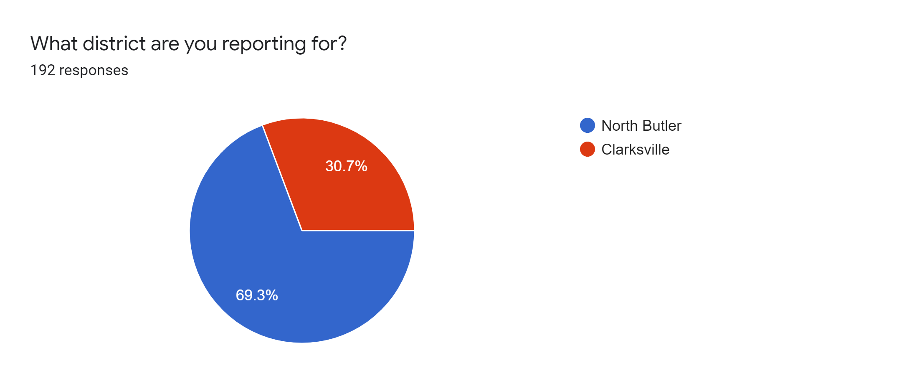

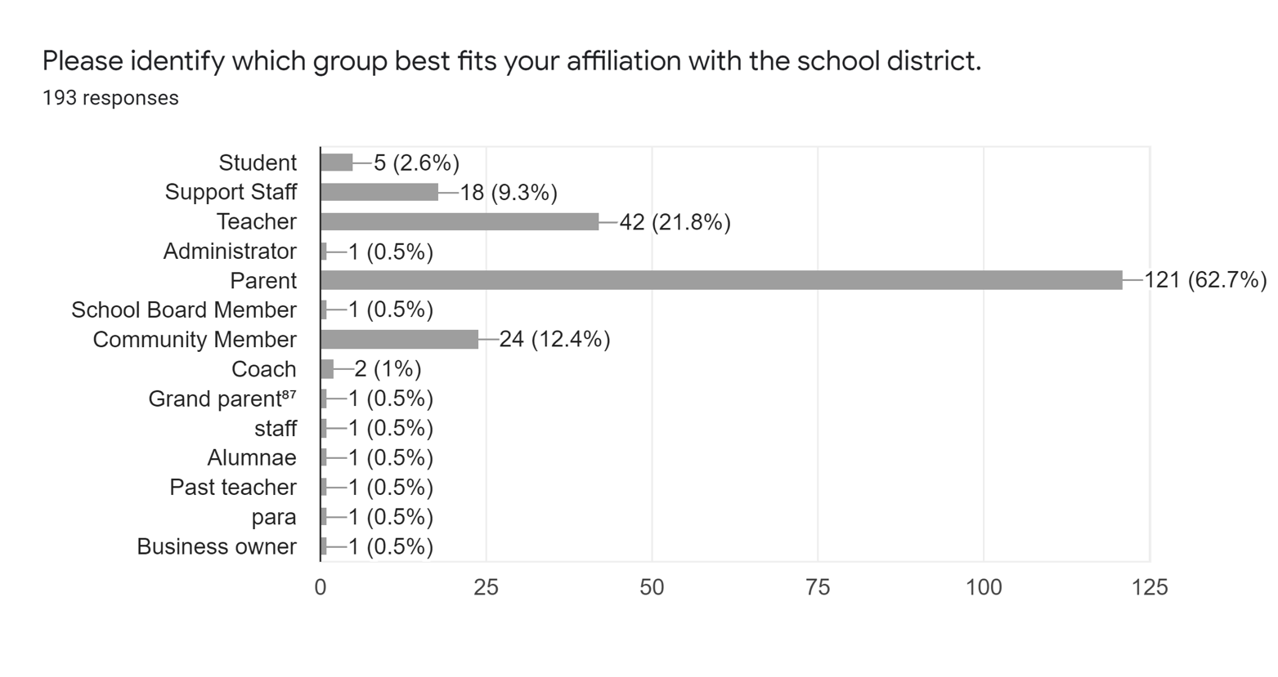

Strengths or points of pride for North Butler include:
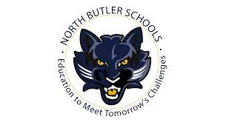
- Community support
- Dedicated teachers and caring support staff
- Involved students
- Support for all extracurriculars including band, vocal, speech, athletics
- Course offerings for all students: college bound, school to work, CTE, etc

I think that North Butler has a lot of community support for the school programs. Our small class size provides for a lot of one on one attention to students. Our district is also very strong on technology with the one to one laptop program and the use of technology during this Covid pandemic.

I am proud of our teachers. We continue to focus on the kids through whatever chaos is going on in the world, community, or school.

Our students are involved in many activities. The district has great teachers who genuinely care for their students. The arts programs starting at an early age are amazing and the students gain self-confidence thru the arts.

We are a small school but have a lot to offer. We have a variety of courses in the junior and high school that students are able to take advantage of. We have sport options and a lot of fun school activities students can get involved in. Our biggest point of pride is our students. We have great students that work hard and enjoy getting involved in multiple activities.

...

Challenges or Areas for Improvement at North Butler:
- Communication
- Unity and cohesion between our towns
- Strong, consistent leadership
- Facility improvements
- Perception of favoritism, not addressing bullying

Communication in all forms: with the community and with staff. Discipline and support for staff.

There is a serious breakdown with communication in our district and there is not a fair equal standard for accountability which started from the top down and needs corrected.

Would love to see more pride and cohesion between all three towns in the district.

Many areas need improvement. We need a strong positive person who really cares about the students and focuses on them and their needs. One who can take lead and be responsible. Need to have good morals and support both communities in our district. Someone who can listen to needs and wants and not let it go in one ear and out the other.

We could use more space and staff to implement programs the way they should be. Maybe it's just a matter of reorganizing where we have our current people and resources. I think our lunch program could use some work.

Acceptance of diversity at NB, whether race, socioeconomic class, sexual orientation, or learning challenges is poor. This has caused anxiety, depression, and suicidal tendencies in several of our students directly resulting from comments made openly in classrooms, halls, locker and lunchrooms. While some may strive to correct this, discipline for these behaviors are minimal if at all. This is another area where zero tolerance should be enforced as it is promised it will be in the student handbook.

Strengths of pride for Clarksville include:

- Great teachers who care about kids
- Strong community support
- Great K-12 facility, small class size
- Being able to remain a one-town school

Great teachers, graduates have been very successful in college and their careers

Small school, supportive community, great staff

Small class size allows for individualized attention.

A small INDEPENDENT district that is able to give all students opportunities. Our small class sizes benefit our students and each student has a chance to contribute to extracurriculars.

We are still on our own, nice facility, and financially stable.
We are still on our own and the facilities are in good shape

Being able to function on its own as a 1A school

Being a one town school

Challenges or Areas for Improvement at Clarksville:

- Retaining staff
- Declining enrollment and funding dollars
- Bullying/discipline
- Communication

Ability to retain and/or attract quality teachers and staff. Being a small school there is turnover and less funds for higher pay.

Retaining and increasing student enrollment numbers

Making sure that bullying is not happening and if it does take care of it immediately. Have open lines of communication with teachers, parents and students.

Better communication with students and teachers upholding the policies of the school, example: wearing hats in school is not appropriate, but all staff needs to speak up when a student is abusing the rule; Need teamwork between the teachers and support staff regarding discipline for bad behavior; appropriate discipline needs to be enforced and upheld by all staff and understood by students - example: everyone needs to be on the same page and know what the next step is to take (This could be a topic of discussion on one of the professional days)

Not as many options (school and sports) as bigger schools, no home ec, multiple foreign languages, technology not as good as other areas, seems like my kids aren't learning what the kids are in the same grade in other schools

Seems once they get out of Elementary the bullying begins and sports seem to still be #1 priority when education should be #1.

Most important professional skills and qualifications (all respondents):
- Recruits, hires, supports develops, and retains effective staff members (70)
- Builds school and community relations (61)
- Effectively manages district resources (56)
- Strong instructional leader (50)

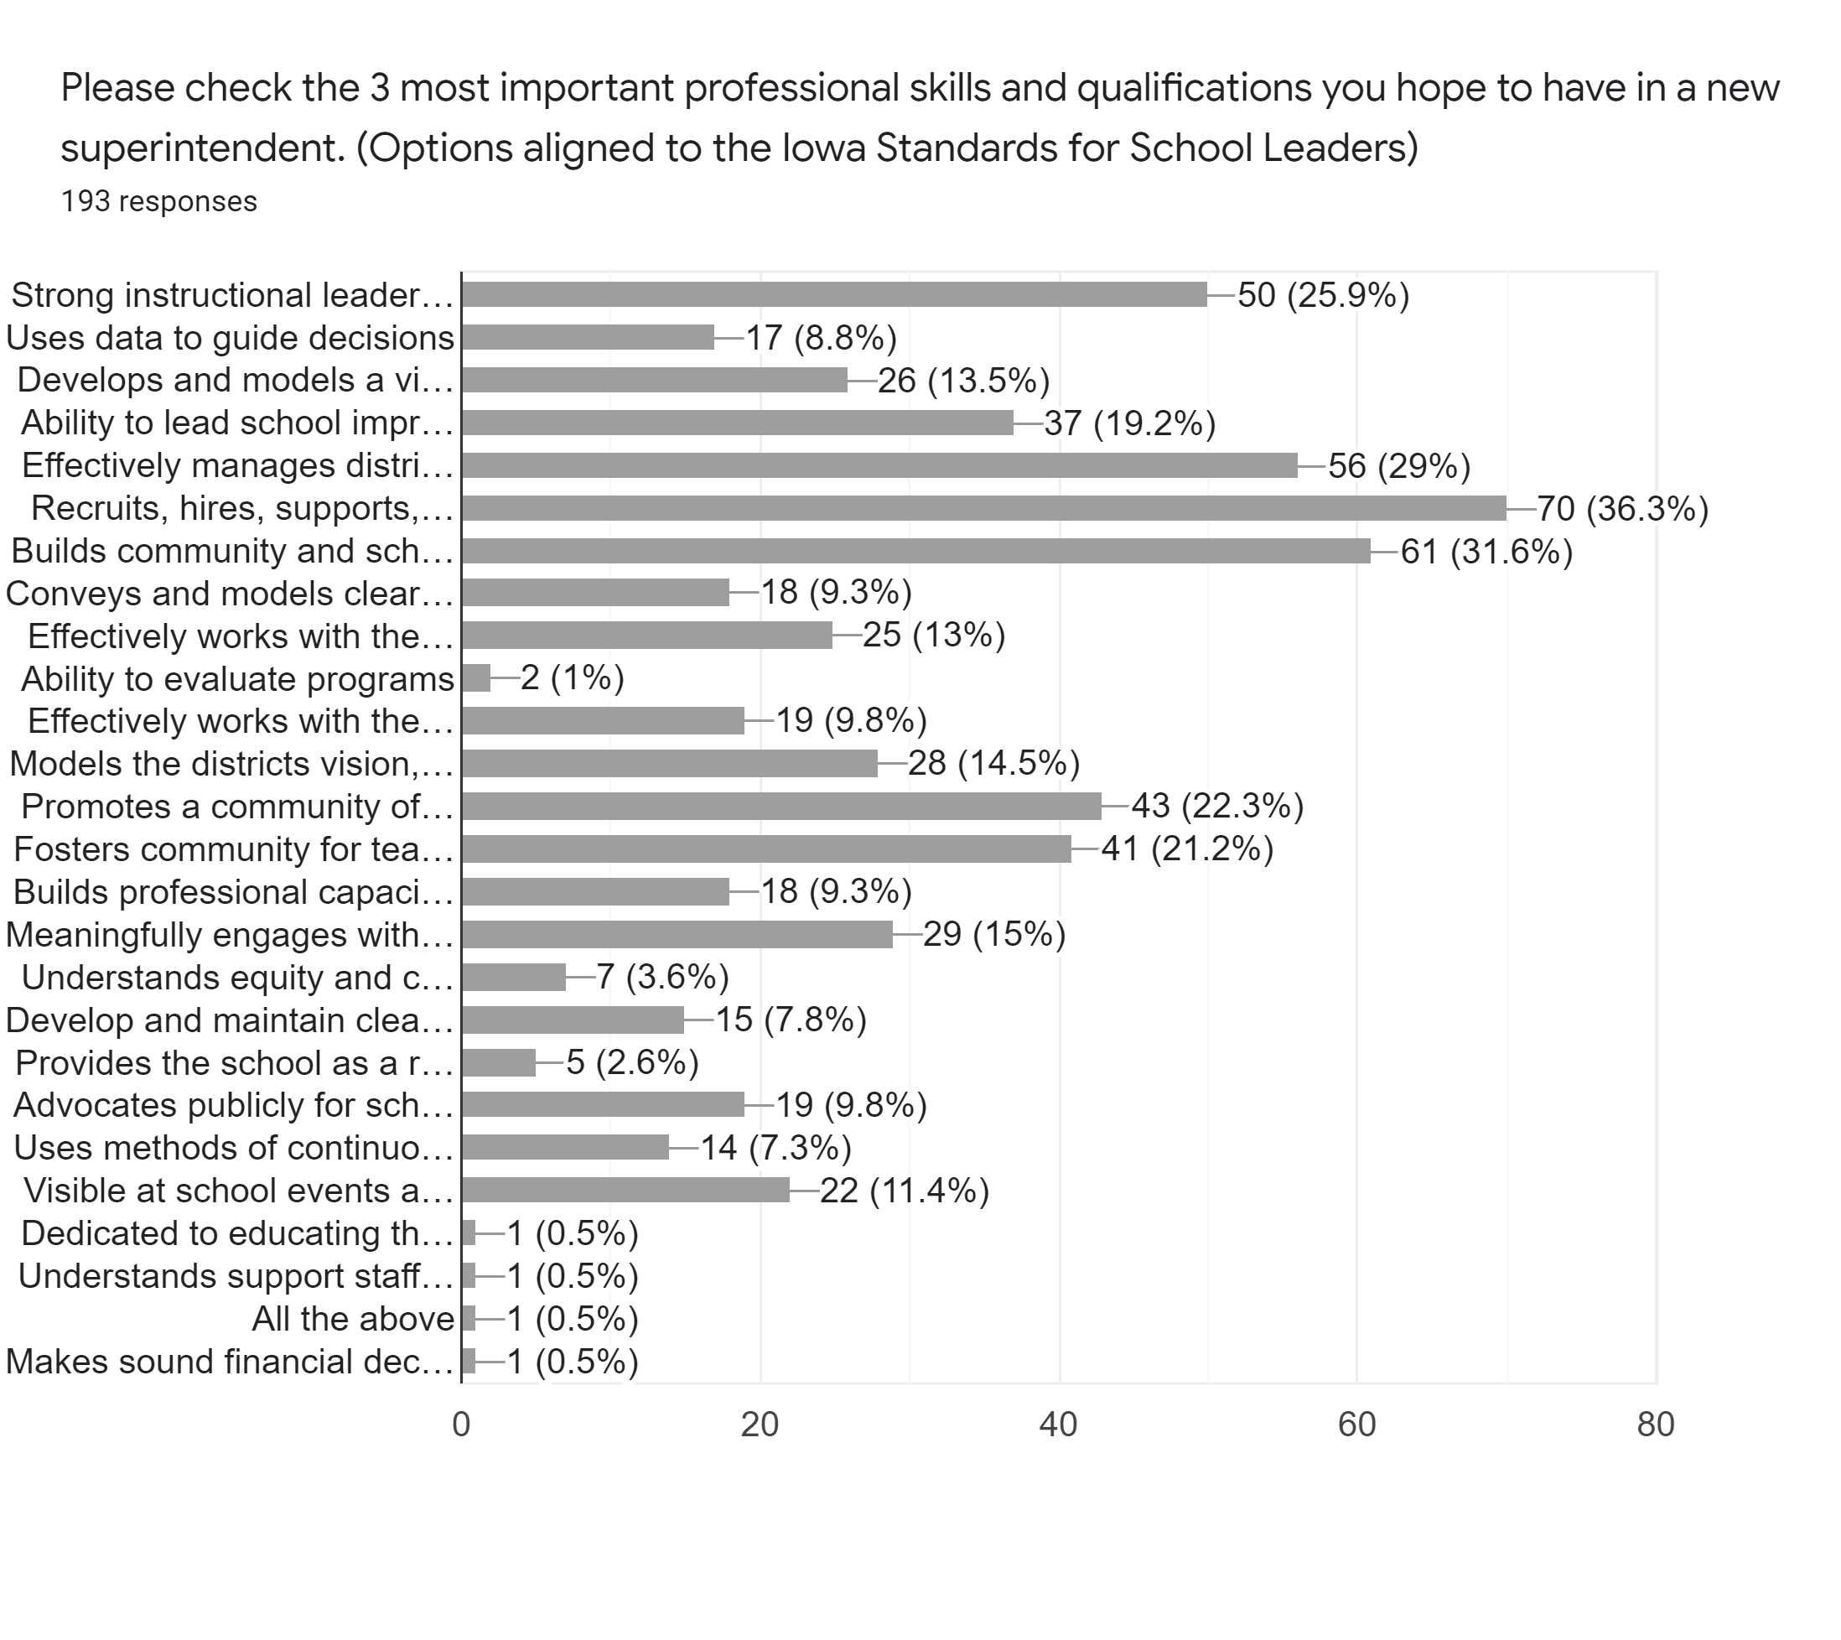

Most important personal traits or qualities:
- Is approachable, accessible, and welcoming (115)
- Follows through on tasks and responsibilities (76)
- Possesses strong communication skills (76)
- Demonstrates ethics and integrity (75)

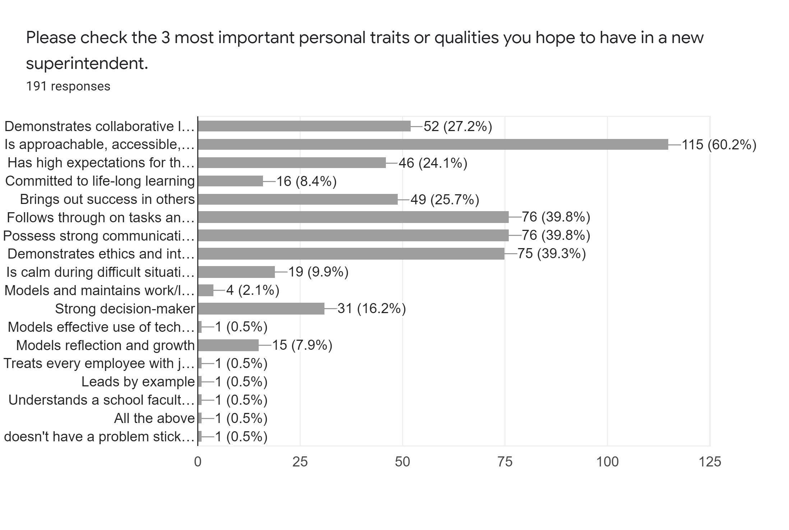

Suggested hiring criteria: (80 pts)

- Recruits, hires, supports develops, and retains effective staff members
- Builds school and community relations
- Effectively manages district resources
- Strong instructional leader
- Is approachable, accessible, and welcoming
- Follows through on tasks and responsibilities
- Possesses strong communication skills
- Demonstrates ethics and integrity

