PCM Stakeholder Survey Report

The PCM School District completed a stakeholder survey from May 19-30 which resulted in 185 total responses from students, teachers, support staff, parents, community members, administrators, and alumni. The results provided some great insights for the district in regard to strengths, areas of concern and what stakeholders are looking for in a new superintendent.

Survey Participation
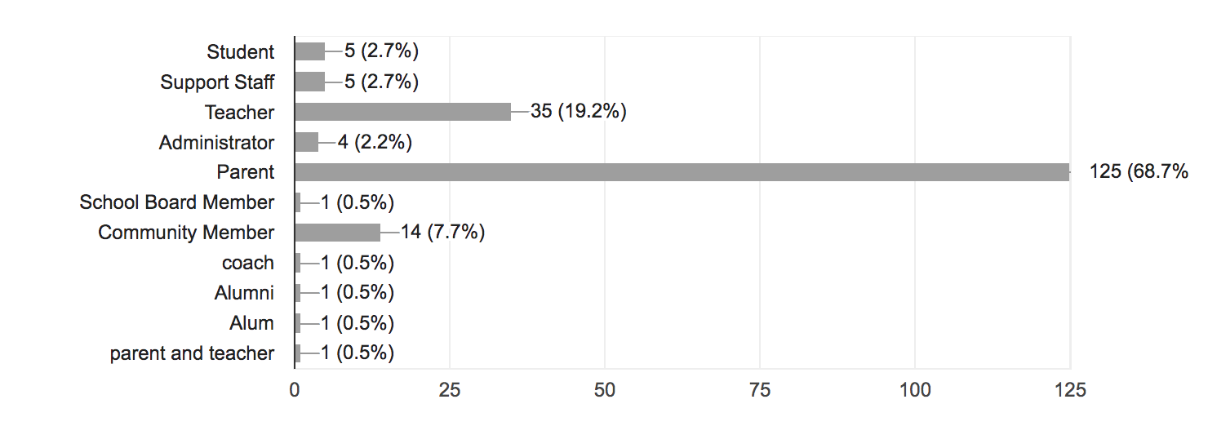

What are the strength areas or points of pride for the PCM School District?

- Dedicated and caring teachers
- Community support for schools
- Small class sizes
- Strong academics
- Communication from district to parents
- Opportunities for students (clubs, sports, fine arts, classes)
- School pride
- Quality district facilities

The teachers!! Teachers care about students success and as individuals. They are excellent at communicating with parents.

I feel our teachers genuinely care about our kids from start to finish. There seems to still be a great deal of pride to be apart of the PCM School District

We have a strong school district with caring teachers. Budget has always been good.

Strong sense of community. Good people who support all activities and the interests of our students.

Lots of classes/electives to choose from. Communication from PCM To the parents is the Best I’ve ever experienced!! Caring Teachers!!

Smaller school with some big school opportunities, strong athletic and music departments

Definitely being able to be in all clubs, music, and sports. Also strong school spirit within the community

Academic excellence. Teachers who really care about their students. Athletic & fine arts programs are on the rise. New football stadium & track.

Our facilities and building are in nice condition. Our teachers are caring, educated, and dedicated.

What are challenges or areas for improvement for the PCM School District?

- Retaining quality teachers
- Balancing sports and academics
- Providing courses options for students
- Maintain financial condition

Need to find ways to keep strong teachers or bring in experience rather than only looking to brand new teachers.

Offering more for non-sports students, adding more academic rigor, helping students think outside of their "small town" minds/boxes, and being more inclusive/accepting of all

Offering more advanced options for students that are college-bound.

Due to the small size of the community I think one of our challenges is for all staff to remain objective, professional and confidential at all times.

More importance placed on academics verse sports, not as many class options offered as larger schools.

A few infrastructure improvements left to do, continue to push academics hard

More importance placed on academics verse sports, not as many class options offered as larger schools.

I feel the budgetary restraints are of the biggest concerns. This is a district where we need to make every dollar count and sometimes get creative.

So much focus in the last few years has been on sports, and academic rigor isn't what it needs to be and fine arts participation is slipping.

Please check the 3 most important professional skills and qualifications you hope to have in a new superintendent.
- Recruits, hires and develops a strong administrative team (57%)
- Strong instructional leader (48%)
- Promotes a community of care and support for students (39%)
- Effectively manages district resources (36%)
- Meaningfully engages with families and the community (33%)
Please check the 3 most important personal traits or qualities you hope to have in a new superintendent.

- Is approachable, accessible and welcoming (75%)
- Demonstrates ethics and integrity (53%)
- Possess strong communication skills (49%)
- Follows through on tasks and responsibilities (46%)
- Demonstrates collaborative leadership (42%)

The superintendent needs to be respected by the staff and community. He/she needs to be involved in community events. He/she needs to be a leader who can support teacher input, concerns and/or questions. He/she needs to be a leader that can stand up for what they believe and not cower when making tough decisions.

We need someone that will bring out the best in everyone through their leadership,. If you can have a good working relationship with someone (as a parent or staff member), you can collaborate and get things done.

These traits and qualifications are important to process so that PCM can continue to support teachers, students and the community, to keep balance between the school and community, and ensure the growth of students academically, physically and mentally.

The PCM superintendent need to effectively communicate with the both the Prairie City and Monroe communities.

We need someone who is great at making decisions and not wishy washy. We also need someone who can maintain our strong leadership by setting the bar high and following through.

We need someone who is friendly and approachable so that personnel, students, and parents can go to him/her if needed. The superintendent needs to be a strong leader who makes decisions that good for our district and follows through on those decisions.

Advice for the new superintendent:

